|  |  |  |  |
| --- | --- | --- | --- |
|  | **COLLEGE OF COMPUTING AND INFORMATION SCIENCES** | | |
| **Assignment-02** | | |
| **Class Id** | 111728 | **Course Title** | OOP |
| **Program** | BSCS | **Campus** | North |
| **Date** | 06-06-2023 | **Total Marks** | 10 |
|  |  | **Faculty Name** | Ramzan Ali Butt |

# Instruction:

* Create a **word document** which contains each question’s

solution with screen shot of output.

* Must attempt all questions by yourself, in case of **copied** solutions your assignment will marked **ZERO.**
* Submit softcopy on **LMS** before deadline.

Save your word document with name: [Student Name Student ID] Submission Deadline: 10/06/2023

# Question – 1 [WINDOWS FORM BASED] [5 marks]

Create a quiz application for two types of student “junior students / senior students”. For both you have to create two levels of quiz question. [High/medium]. Each level contains 5 quiz question and each question contains 3 answers options it’s very simple, now run your mind to create GUI and:

# Apply OOP concepts:

1: classes

2: Constructor overloading

3: static keyword

4: methods

Use an appropriate GUI controls to create a best design from your side.

Show the correct answers and wrong answers at the end of the quiz program.

[Add screen shots of code and screen shots of outputs]

Outputs

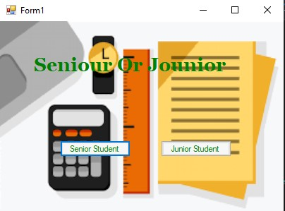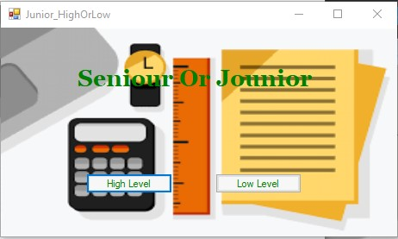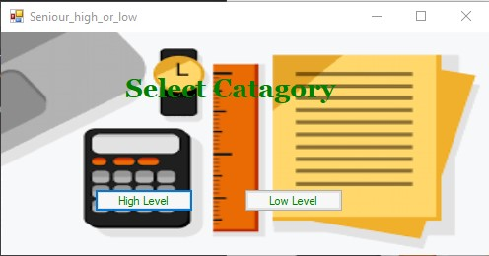

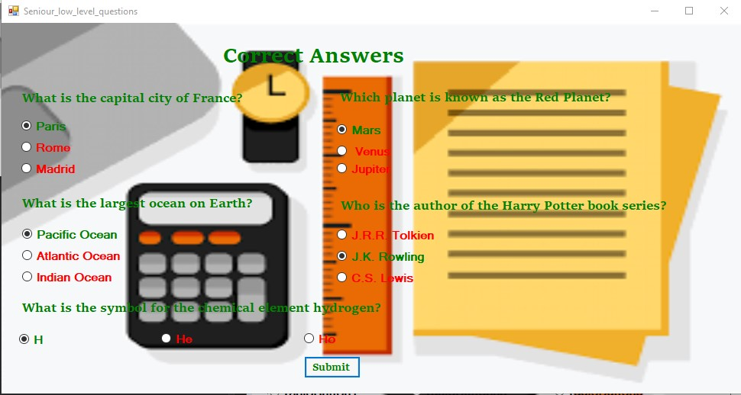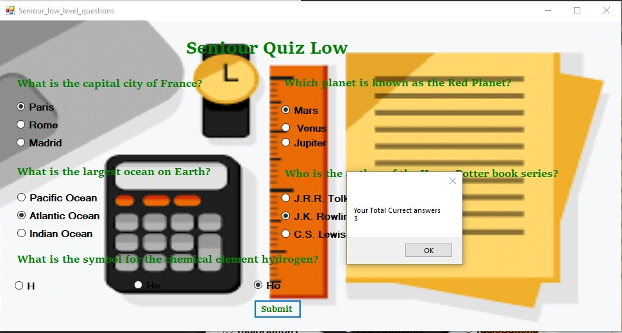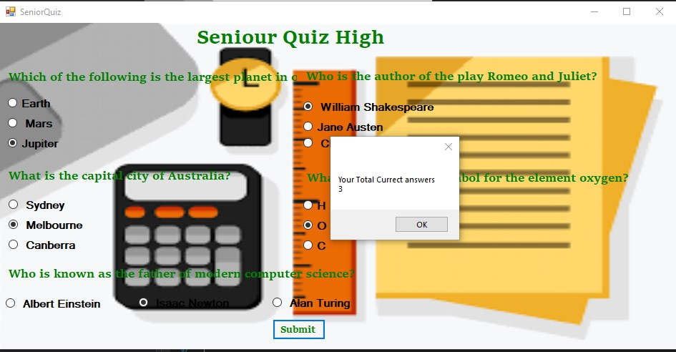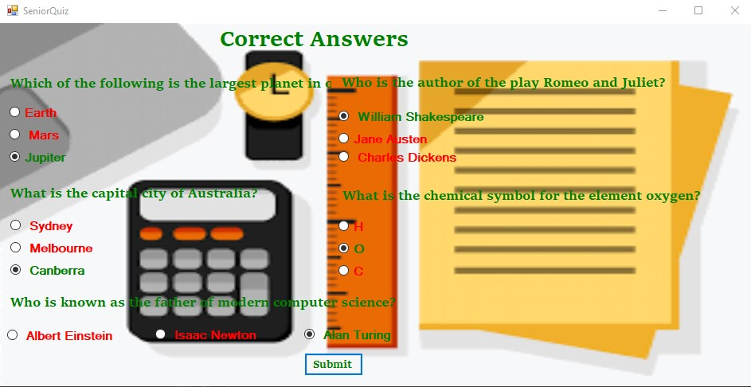

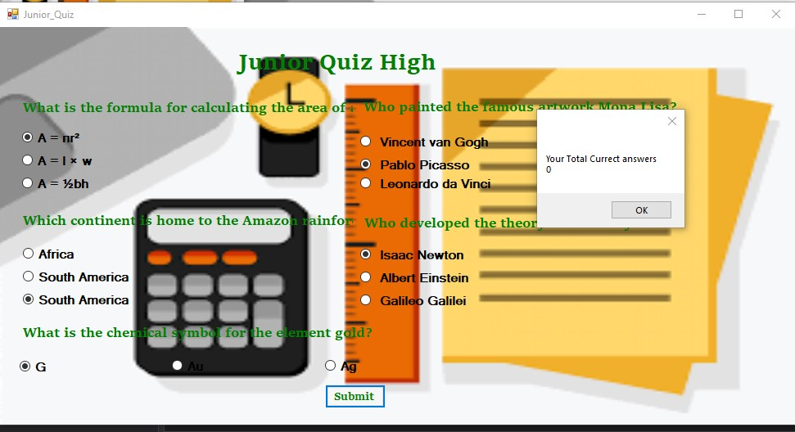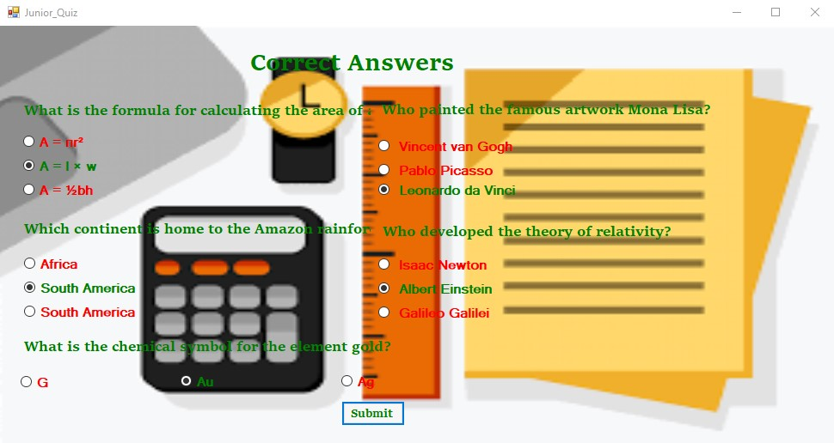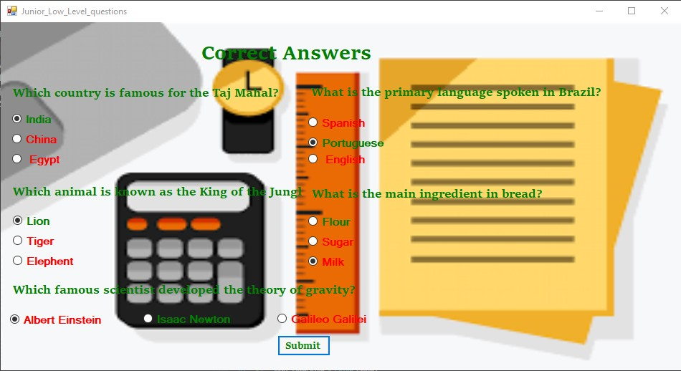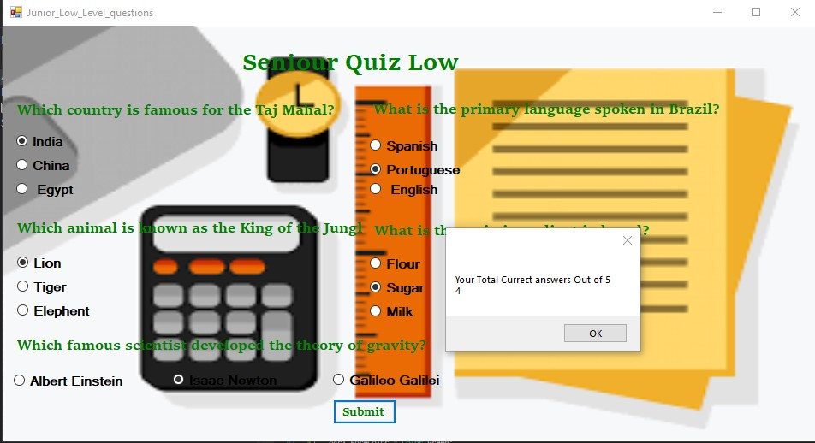

Code

using System;

using System.Collections.Generic;

using System.ComponentModel;

using System.Data;

using System.Drawing;

using System.Linq;

using System.Text;

using System.Threading.Tasks;

using System.Windows.Forms;

namespace Question_1

{

public partial class Form1 : Form

{

public Form1()

{

InitializeComponent();

}

private void label1_Click(object sender, EventArgs e)

{

}

private void BtnSenior_Click(object sender, EventArgs e)

{

Seniour_high_or_low sn = new Seniour_high_or_low();

sn.Show();

}

private void btnjunior_Click(object sender, EventArgs e)

{

Junior_HighOrLow j = new Junior_HighOrLow();

j.Show();

}

}

}using System;

using System.Collections.Generic;

using System.ComponentModel;

using System.Data;

using System.Drawing;

using System.Linq;

using System.Text;

using System.Threading.Tasks;

using System.Windows.Forms;

namespace Question_1

{

public partial class Seniour_high_or_low : Form

{

public Seniour_high_or_low()

{

InitializeComponent();

}

private void Seniour_high_or_low_Load(object sender, EventArgs e)

{

}

private void High_Level_Click(object sender, EventArgs e)

{

this.Close();

SeniorQuiz sn = new SeniorQuiz();

sn.Show();

}

private void Low_level_Click(object sender, EventArgs e)

{

Seniour_low_level_questions snl = new Seniour_low_level_questions();

snl.Show();

}

}

}

using System;

using System.Collections.Generic;

using System.ComponentModel;

using System.Data;

using System.Drawing;

using System.Linq;

using System.Text;

using System.Threading.Tasks;

using System.Windows.Forms;

namespace Question_1

{

public partial class SeniorQuiz : Form

{

private void btnrefresh_Click(object sender, EventArgs e)

{

this.Close();

SeniorQuiz sn = new SeniorQuiz();

sn.Show();

}

private void btnsubmit_Click(object sender, EventArgs e)

{

if (q1r3.Checked == true) { Seniour_Data.count++; }

if (q2r1.Checked == true) { Seniour_Data.count++; }

if (q3r3.Checked == true) { Seniour_Data.count++; }

if (q4r2.Checked == true) { Seniour_Data.count++; }

if (q5r3.Checked == true) { Seniour_Data.count++; }

MessageBox.Show("Your Total Currect answers \n" + Seniour_Data.count.ToString());

label1.Text = "Correct Answers";

q1r3.Checked = true;

q2r1.Checked = true;

q3r3.Checked = true;

q4r2.Checked = true;

q5r3.Checked = true;

q5r3.ForeColor = Color.Green;

q2r1.ForeColor = Color.Green;

q1r3.ForeColor = Color.Green;

q3r1.ForeColor = Color.Red;

q4r3.ForeColor = Color.Red;

q5r1.ForeColor = Color.Red;

q1r1.ForeColor = Color.Red;

q1r2.ForeColor = Color.Red;

q3r3.ForeColor = Color.Green;

q2r2.ForeColor = Color.Red;

q2r3.ForeColor = Color.Red;

q3r2.ForeColor = Color.Red;

q4r2.ForeColor = Color.Green;

q4r1.ForeColor = Color.Red;

q5r2.ForeColor = Color.Red;

q1r1.ForeColor = Color.Red;

}

public SeniorQuiz()

{

InitializeComponent();

Seniour_Data.Q1= "Which of the following is the largest planet in our solar system?";

Seniour_Data.Q2 = "Who is the author of the play Romeo and Juliet?";

Seniour_Data.Q3 = "What is the capital city of Australia?";

Seniour_Data.Q4 = "What is the chemical symbol for the element oxygen?";

Seniour_Data.Q5 = "Who is known as the father of modern computer science?";

SeniorQuiz sn = new SeniorQuiz(

new string[] { "Earth", " Mars", "Jupiter " },

new string[] { " William Shakespeare ", "Jane Austen", " Charles Dickens" },

new string[] { " Sydney", " Melbourne", " Canberra" },

new string[] { "H", "O", "C" },

new string[] { " Albert Einstein", " Isaac Newton", " Alan Turing " }

);

}

public SeniorQuiz(string[] P1, string[] P2, string[] P3, string[] P4, string[] P5)

{

for(int i = 0; i < 3; i++)

{

Seniour_Data.P1[i] = P1[i];

Seniour_Data.P2[i] = P2[i];

Seniour_Data.P3[i] = P3[i];

Seniour_Data.P4[i] = P4[i];

Seniour_Data.P5[i] = P5[i];

}

}

private void question1_Click(object sender, EventArgs e)

{

}

private void SeniorQuiz_Load(object sender, EventArgs e)

{

Label_1.Text = Seniour_Data.Q1;

Label_1.Show();

Label_2.Text = Seniour_Data.Q2;Label_2.Show();

Label_3.Text = Seniour_Data.Q3;Label_3.Show();

Label_4.Text = Seniour_Data.Q4; Label_4.Show();

Label_5.Text = Seniour_Data.Q5; Label_5.Show();

q1r1.Text = Seniour_Data.P1[0];

q1r2.Text = Seniour_Data.P1[1];

q1r3.Text = Seniour_Data.P1[2];

q2r1.Text = Seniour_Data.P2[0];

q2r2.Text = Seniour_Data.P2[1];

q2r3.Text = Seniour_Data.P2[2];

q3r1.Text = Seniour_Data.P3[0];

q3r2.Text = Seniour_Data.P3[1];

q3r3.Text = Seniour_Data.P3[2];

q4r1.Text = Seniour_Data.P4[0];

q4r2.Text = Seniour_Data.P4[1];

q4r3.Text = Seniour_Data.P4[2];

q5r1.Text = Seniour_Data.P5[0];

q5r2.Text = Seniour_Data.P5[1];

q5r3.Text = Seniour_Data.P5[2];

}

}

}

sing System;

using System.Collections.Generic;

using System.ComponentModel;

using System.Data;

using System.Drawing;

using System.Linq;

using System.Text;

using System.Threading.Tasks;

using System.Windows.Forms;

namespace Question_1

{

public partial class Seniour_low_level_questions : Form

{

public Seniour_low_level_questions()

{

InitializeComponent();

Seniour_Data.Q1 = "What is the capital city of France?";

Seniour_Data.Q2 = "Which planet is known as the Red Planet?";

Seniour_Data.Q3 = "What is the largest ocean on Earth?";

Seniour_Data.Q4 = "Who is the author of the Harry Potter book series?";

Seniour_Data.Q5 = "What is the symbol for the chemical element hydrogen?";

SeniorQuiz sn = new SeniorQuiz(

new string[] { "Paris", "Rome", "Madrid" },

new string[] { "Mars", " Venus", "Jupiter" },

new string[] { "Pacific Ocean", "Atlantic Ocean", "Indian Ocean" },

new string[] { "J.R.R. Tolkien", "J.K. Rowling ", "C.S. Lewis" },

new string[] { "H", "He", "Ho" }

);

}

public Seniour_low_level_questions(string[] P1, string[] P2, string[] P3, string[] P4, string[] P5)

{

for (int i = 0; i < 3; i++)

{

Seniour_Data.P1[i] = P1[i];

Seniour_Data.P2[i] = P2[i];

Seniour_Data.P3[i] = P3[i];

Seniour_Data.P4[i] = P4[i];

Seniour_Data.P5[i] = P5[i];

}

}

private void Seniour_low_level_questions_Load(object sender, EventArgs e)

{

Label_1.Text = Seniour_Data.Q1;

Label_2.Text = Seniour_Data.Q2; Label_2.Show();

Label_3.Text = Seniour_Data.Q3; Label_3.Show();

Label_4.Text = Seniour_Data.Q4; Label_4.Show();

Label_5.Text = Seniour_Data.Q5; Label_5.Show();

q1r1.Text = Seniour_Data.P1[0];

q1r2.Text = Seniour_Data.P1[1];

q1r3.Text = Seniour_Data.P1[2];

q2r1.Text = Seniour_Data.P2[0];

q2r2.Text = Seniour_Data.P2[1];

q2r3.Text = Seniour_Data.P2[2];

q3r1.Text = Seniour_Data.P3[0];

q3r2.Text = Seniour_Data.P3[1];

q3r3.Text = Seniour_Data.P3[2];

q4r1.Text = Seniour_Data.P4[0];

q4r2.Text = Seniour_Data.P4[1];

q4r3.Text = Seniour_Data.P4[2];

q5r1.Text = Seniour_Data.P5[0];

q5r2.Text = Seniour_Data.P5[1];

q5r3.Text = Seniour_Data.P5[2];

}

private void btnsubmit_Click_1(object sender, EventArgs e)

{

if (q1r1.Checked == true) { Seniour_Data.count++; }

if (q2r1.Checked == true) { Seniour_Data.count++; }

if (q3r1.Checked == true) { Seniour_Data.count++; }

if (q4r2.Checked == true) { Seniour_Data.count++; }

if (q5r1.Checked == true) { Seniour_Data.count++; }

MessageBox.Show("Your Total Currect answers \n" + Seniour_Data.count.ToString());

label1.Text = "Correct Answers";

q1r1.Checked = true;

q2r1.Checked = true;

q3r1.Checked = true;

q4r2.Checked = true;

q5r1.Checked = true;

q1r1.ForeColor = Color.Green;

q2r1.ForeColor = Color.Green;

q3r1.ForeColor = Color.Green;

q4r2.ForeColor = Color.Green;

q5r1.ForeColor = Color.Green;

q1r2.ForeColor = Color.Red;

q1r3.ForeColor = Color.Red;

q2r2.ForeColor = Color.Red;

q2r3.ForeColor = Color.Red;

q3r2.ForeColor = Color.Red;

q3r3.ForeColor = Color.Red;

q4r1.ForeColor = Color.Red;

q4r3.ForeColor = Color.Red;

q5r2.ForeColor = Color.Red;

q5r3.ForeColor = Color.Red;

}

}}

**Junior**

using System;

using System.Collections.Generic;

using System.ComponentModel;

using System.Data;

using System.Drawing;

using System.Linq;

using System.Text;

using System.Threading.Tasks;

using System.Windows.Forms;

namespace Question_1

{

public partial class Junior_HighOrLow : Form

{

public Junior_HighOrLow()

{

InitializeComponent();

}

private void High_Level_Click(object sender, EventArgs e)

{

Junior_Quiz jn = new Junior_Quiz();

this.Close();

jn.Show();

}

private void Low_level_Click(object sender, EventArgs e)

{

Junior_Low_Level_questions jn = new Junior_Low_Level_questions();

this.Close();

jn.Show();

}

}

}

using System;

using System.Collections.Generic;

using System.ComponentModel;

using System.Data;

using System.Drawing;

using System.Linq;

using System.Text;

using System.Threading.Tasks;

using System.Windows.Forms;

namespace Question_1

{

public partial class Junior_Quiz : Form

{

public Junior_Quiz()

{

InitializeComponent();

Juniour_Data.Q1 = "What is the formula for calculating the area of a rectangle?";

Juniour_Data.Q2 = "Who painted the famous artwork Mona Lisa?";

Juniour_Data.Q3 = "Which continent is home to the Amazon rainforest?";

Juniour_Data.Q4 = "Who developed the theory of relativity?";

Juniour_Data.Q5 = "What is the chemical symbol for the element gold?";

Junior_Quiz sn = new Junior_Quiz(

new string[] { "A = πr²", "A = l × w ", "A = ½bh" },

new string[] { " Vincent van Gogh", " Pablo Picasso", " Leonardo da Vinci " },

new string[] { "Africa", "South America ", "South America " },

new string[] { " Isaac Newton", " Albert Einstein", " Galileo Galilei" },

new string[] { "G", "Au", "Ag" }

);

}

public Junior_Quiz(string[] P1, string[] P2, string[] P3, string[] P4, string[] P5)

{

for (int i = 0; i < 3; i++)

{

Juniour_Data.P1[i] = P1[i];

Juniour_Data.P2[i] = P2[i];

Juniour_Data.P3[i] = P3[i];

Juniour_Data.P4[i] = P4[i];

Juniour_Data.P5[i] = P5[i];

}

}

private void label1_Click(object sender, EventArgs e)

{

}

private void Junior_Quiz_Load(object sender, EventArgs e)

{

Label_1.Text = Juniour_Data.Q1;

Label_1.Show();

Label_2.Text = Juniour_Data.Q2; Label_2.Show();

Label_3.Text = Juniour_Data.Q3; Label_3.Show();

Label_4.Text = Juniour_Data.Q4; Label_4.Show();

Label_5.Text = Juniour_Data.Q5; Label_5.Show();

q1r1.Text = Juniour_Data.P1[0];

q1r2.Text = Juniour_Data.P1[1];

q1r3.Text = Juniour_Data.P1[2];

q2r1.Text = Juniour_Data.P2[0];

q2r2.Text = Juniour_Data.P2[1];

q2r3.Text = Juniour_Data.P2[2];

q3r1.Text = Juniour_Data.P3[0];

q3r2.Text = Juniour_Data.P3[1];

q3r3.Text = Juniour_Data.P3[2];

q4r1.Text = Juniour_Data.P4[0];

q4r2.Text = Juniour_Data.P4[1];

q4r3.Text = Juniour_Data.P4[2];

q5r1.Text = Juniour_Data.P5[0];

q5r2.Text = Juniour_Data.P5[1];

q5r3.Text = Juniour_Data.P5[2];

}

private void btnsubmit_Click_1(object sender, EventArgs e)

{

if (q1r2.Checked == true) { Juniour_Data.count++; }

if (q2r3.Checked == true) { Juniour_Data.count++; }

if (q3r2.Checked == true) { Juniour_Data.count++; }

if (q4r2.Checked == true) { Juniour_Data.count++; }

if (q5r2.Checked == true) { Juniour_Data.count++; }

MessageBox.Show("Your Total Currect answers \n" + Juniour_Data.count.ToString());

label1.Text = "Correct Answers";

q1r2.Checked = true;

q2r3.Checked = true;

q3r2.Checked = true;

q4r2.Checked = true;

q5r2.Checked = true;

q1r2.ForeColor = Color.Green;

q2r1.ForeColor = Color.Red;

q3r1.ForeColor = Color.Red;

q4r3.ForeColor = Color.Red;

q5r1.ForeColor = Color.Red;

q1r1.ForeColor = Color.Red;

q1r3.ForeColor = Color.Red;

q2r2.ForeColor = Color.Red;

q2r3.ForeColor = Color.Green;

q3r2.ForeColor = Color.Green;

q3r3.ForeColor = Color.Red;

q4r1.ForeColor = Color.Red;

q4r2.ForeColor = Color.Green;

q5r2.ForeColor = Color.Green;

q5r3.ForeColor = Color.Red;

}

}

}

using System;

using System.Collections.Generic;

using System.ComponentModel;

using System.Data;

using System.Drawing;

using System.Linq;

using System.Text;

using System.Threading.Tasks;

using System.Windows.Forms;

namespace Question_1

{

public partial class Junior_Low_Level_questions : Form

{

public Junior_Low_Level_questions()

{

InitializeComponent();

Juniour_Data.Q1 = "Which country is famous for the Taj Mahal?";

Juniour_Data.Q2 = "What is the primary language spoken in Brazil?";

Juniour_Data.Q3 = "Which animal is known as the King of the Jungle?";

Juniour_Data.Q4 = "What is the main ingredient in bread?";

Juniour_Data.Q5 = "Which famous scientist developed the theory of gravity?";

Junior_Low_Level_questions sn = new Junior_Low_Level_questions(

new string[] { "India", "China", " Egypt" },

new string[] { "Spanish", "Portuguese ", " English" },

new string[] { "Lion", "Tiger", "Elephent" },

new string[] { "Flour", "Sugar", "Milk" },

new string[] { "Albert Einstein", "Isaac Newton", "Galileo Galilei" }

);

}

public Junior_Low_Level_questions(string[] P1, string[] P2, string[] P3, string[] P4, string[] P5)

{

for (int i = 0; i < 3; i++)

{

Juniour_Data.P1[i] = P1[i];

Juniour_Data.P2[i] = P2[i];

Juniour_Data.P3[i] = P3[i];

Juniour_Data.P4[i] = P4[i];

Juniour_Data.P5[i] = P5[i];

}

}

private void Junior_Low_Level_questions_Load(object sender, EventArgs e)

{

Label_1.Text = Juniour_Data.Q1;

Label_1.Show();

Label_2.Text = Juniour_Data.Q2; Label_2.Show();

Label_3.Text = Juniour_Data.Q3; Label_3.Show();

Label_4.Text = Juniour_Data.Q4; Label_4.Show();

Label_5.Text = Juniour_Data.Q5; Label_5.Show();

q1r1.Text = Juniour_Data.P1[0];

q1r2.Text = Juniour_Data.P1[1];

q1r3.Text = Juniour_Data.P1[2];

q2r1.Text = Juniour_Data.P2[0];

q2r2.Text = Juniour_Data.P2[1];

q2r3.Text = Juniour_Data.P2[2];

q3r1.Text = Juniour_Data.P3[0];

q3r2.Text = Juniour_Data.P3[1];

q3r3.Text = Juniour_Data.P3[2];

q4r1.Text = Juniour_Data.P4[0];

q4r2.Text = Juniour_Data.P4[1];

q4r3.Text = Juniour_Data.P4[2];

q5r1.Text = Juniour_Data.P5[0];

q5r2.Text = Juniour_Data.P5[1];

q5r3.Text = Juniour_Data.P5[2];

}

private void btnsubmit_Click_1(object sender, EventArgs e)

{

if (q1r1.Checked == true) { Juniour_Data.count++; }

if (q2r2.Checked == true) { Juniour_Data.count++; }

if (q3r1.Checked == true) { Juniour_Data.count++; }

if (q4r1.Checked == true) { Juniour_Data.count++; }

if (q5r2.Checked == true) { Juniour_Data.count++; }

MessageBox.Show("Your Total Currect answers Out of 5 \n" + Juniour_Data.count.ToString());

label1.Text = "Correct Answers";

q1r1.Checked = true;

q2r2.Checked = true;

q3r1.Checked = true;

q4r3.Checked = true;

q5r1.Checked = true;

q1r2.ForeColor = Color.Red;

q2r1.ForeColor = Color.Red;

q3r1.ForeColor = Color.Green;

q4r3.ForeColor = Color.Red;

q5r1.ForeColor = Color.Red;

q1r1.ForeColor = Color.Green;

q1r3.ForeColor = Color.Red;

q2r2.ForeColor = Color.Green;

q2r3.ForeColor = Color.Red;

q3r2.ForeColor = Color.Red;

q3r3.ForeColor = Color.Red;

q4r1.ForeColor = Color.Green;

q4r2.ForeColor = Color.Red;

q5r2.ForeColor = Color.Green;

q5r3.ForeColor = Color.Red;

}

}

}

**Classes**

using System;

using System.Collections.Generic;

using System.Linq;

using System.Text;

using System.Threading.Tasks;

namespace Question_1

{

class Juniour_Data

{

public static string Q1, Q2, Q3, Q4, Q5;

public static string[] P1 = new string[5];

public static string[] P2 = new string[5];

public static string[] P3 = new string[5];

public static string[] P4 = new string[5];

public static string[] P5 = new string[5];

public static int count;

}

}

using System;

using System.Collections.Generic;

using System.Linq;

using System.Text;

using System.Threading.Tasks;

namespace Question_1

{

class Seniour_Data

{

public static string Q1, Q2, Q3, Q4, Q5;

public static string[] P1 = new string[5];

public static string[] P2 = new string[5];

public static string[] P3 = new string[5];

public static string[] P4 = new string[5];

public static string[] P5 = new string[5];

public static int count;

}

}

**Question – 2 [CONSOLE BASED ] [5 mark]**

Perform the following question and apply appropriate OOP concept.

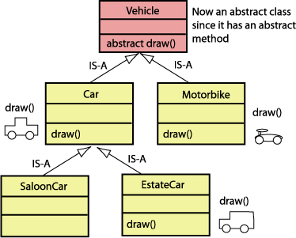

**Code**

using System;

using System.Collections.Generic;

using System.Linq;

using System.Text;

using System.Threading.Tasks;

namespace Question_2

{

public abstract class Vehicle

{

public abstract void Draw();

}

class Car : Vehicle

{

public override void Draw()

{

Console.WriteLine("This is Car");

}

}

class Saloon : Car

{

public Saloon()

{

base.Draw();

}

}

class EstateCar : Car

{

public override void Draw()

{

Console.WriteLine("\nThis is Estate Vihicle");

}

}

class MotorBike : Vehicle

{

public override void Draw()

{

Console.WriteLine("\nThis Is motorCycle Diagram");

}

}

class Program

{

static void Main(string[] args)

{

Saloon s1 = new Saloon();

EstateCar es1 = new EstateCar();

es1.Draw();

MotorBike m1 = new MotorBike();

m1.Draw();

}

}

}

